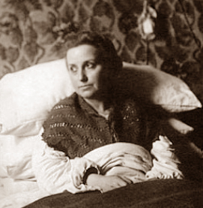
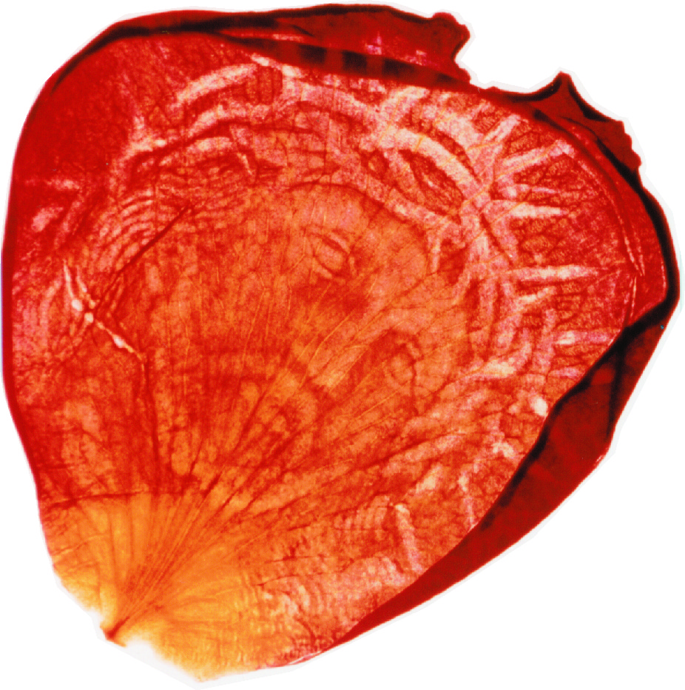
E-BULLETIN NO. 56, DECEMBER 2009
MARIA VALTORTA READERS’ GROUP, AUSTRALIA
11 Best Street, Ringwood, Vic. 3134. Tel. +61 3 9879 7853
E-mail: valtorta@alphalink.com.au
Web-site: http://valtorta.alphalink.com.au

(Jesus to Maria): “Let us turn to the little sheep, seeking to be
acquainted with their Master. It is I, and you are the staff,
leading them to Me.” (The Poem of the Man-God, Vol. 1, p. 246)
The Lord bless you and keep you; The Lord make His Face shine upon you, and be gracious to you; The Lord lift up His countenance upon you, and give you peace. (Num. 6:24-6.)
“Lord, I do not ask You for the glory of your visions, but for the grace to love You more and more.”
(Notebooks 1944, p. 439.)

“Publish this work as it is… whoever reads it will understand…”

– Pope Pius XII (26th February 1948)

Dear Readers’ Group Members,
Valtorta readers often say how Maria’s writings tend to “spoil” them from reading other holy books. Also, those who read Maria’s books invariably say that each time they re-read a Valtorta book, something “jumps out at them” that they had read before but hadn’t taken in.
In my first reading of The Poem, I took copious notes. There were so many passages I wanted to be able to find again. Little did I know that these notes led to the development of the “Thematic Index” which continues to grow with every new edition of the “Pilgrim’s Guide to The Poem...” (the 4th edition is now on the drawing board).
In my second reading of The Poem I made a startling discovery. There was an area of my life which needed dealing with, and I hadn’t made one single note concerning passages in The Poem which clarified this area! I eventually came to terms with this - with ultimate peace – and my life underwent a major transformation.
This discovery process has never ceased to continue. While assembling a second edition of a “Reader’s Guide to Maria Valtorta’s Other Writings” (her books other than The Poem), I re-discovered passages in these books – some of which I’d read before but forgotten about - which give significant clarification to issues concerning the extraordinary benefits gained by a multitude of Valtorta readers around the world, and concerning the lack of acceptance of Maria’s writings in some quarters within the Catholic Church. I set to work assembling a list of these, and this list has developed – like the old photographic process of film development – into three distinctive parts or sections:
1. Maria’s suffering and saintly life, her mission, and her later withdrawal as foreshadowed (four sub-headings).
2. The process of how she received and recorded the visions and dictations, the dramatic events leading to publication of The Poem of the Man-God, and its delayed but now growing world-wide acceptance (six sub-headings).
3. A virtual treasure chest of insights and teachings from Maria’s “other writings”, for our survival and spiritual growth in a hostile world. These will be wonderful resource material for bulletins, booklets and whatever, and some of these passages are included with this bulletin (see page 2) and the supplement.
Guided by ideas which day after day came to mind during my morning prayers, and helped by conversations with my friend Ed Ford, parts 1 and 2 have been assembled into a new Readers’ Group 72-page little book:
MARIA VALTORTA – A VICTIM SOUL
Her Saintly Life, Mission and Writings

This is the book’s front cover, now being published, and it should be available about 8th December (Feast of Mary’s Immaculate Conception). Its cost: $Aust 10.00. Email me for purchasing information.
(Here is some feedback from a contributor to a well-known Internet Encyclopaedia:)
“This book brings together and interleaves many items that would have gone unnoticed... and provides a "first ever" look at the actual sequence of events in her life. Hence for the "believers" it is an essential fact book... It includes several key statements... and shows your detailed knowledge of her work. It is very impressive in that sense...”
(And from the webmaster of a popular Valtorta site:)
I carefully read over [the last two chapters] as you requested. I think they are an excellent summation of the history of Valtorta's [rather Christ's] "Poem..." and provide a fine update for refuting any further objections to the Work as being condemned by the Church. I would appreciate a copy of the booklet if possible when you finish it.
Below is a dictation from Jesus which has relevance to the opening paragraphs of this bulletin.
Wishing you all a happy and holy Christmas, May God bless you and keep you.
David D. Murray
Assistant Convenor.

(Jesus answers two concerns Maria had expressed to Him. He says:)
"Some days ago you said you are dying without having fulfilled the desire to see the Holy Places. You see them, and it is the way they were when I sanctified them with My presence. Now, after twenty centuries of profanations arising from hate or love, they are no longer the way they were. Consider, then, that you see them, and those going to Palestine do not. And do not be saddened by this.
"The second point: you complain that even those books which speak of Me seem to hold no relish for you any longer, whereas you greatly loved them before. This also comes from your present condition. How can you want human works to seem more perfect to you, when you know the truth of events through My action? It is what happens with even good translations. They always mutilate the energy of the original phrase. Human descriptions - whether they be of places, events, or feelings - are 'translations' and thus always incomplete, inexact, if not in words and events, in feelings. Especially now that rationalism has brought such sterility. Consequently, when one is led by Me to see and know, every other description is cold and leaves one dissatisfied and displeased..."
(Notebooks 1944, p. 197)
A member was wondering if our readers have other non-Catholic friends or family who have read The Poem, and what their comments may be.
Please advise, if you have, - Ed.
I’ve stopped worrying about tomorrow!
After all, today is the tomorrow I worried about yesterday!

THE MIND AND THE SOUL
(Jesus says:)
"I have given you my Love and my Blood. I have given you my Word and my
Body. But I want to give you more than the Word. I want to give you my Thought.
"What is thought? It is the soul of the word. When two people love one another, they are satisfied with saying necessary words, but communicate their intimate thoughts as well. Oh, the joy of being able to say to those who love us what, like a lightning bolt, like music, like a throb, is burning in our mind and through this burning distinguishes us from the beasts, whose mental movements are limited to the rudimentary needs of life!
"Man thinks, and from thought he draws the masterworks of art, genius, and beauty. Man thinks, and in this thought of his he has an intimate friend who fills even the solitude of the hermit with company. Man's thought, spiritual as it is, freely roams throughout the universe. It plunges into the remembrance of distant ages, immerses itself in prevision of times to come, studies and contemplates and meditates on God's wonderful works in creation, and reflects on the mysteries of men (every man is a mystery enclosed in a mortal robe: luminous or dark, according to his holy or Satanic spirit, a mystery known only to God, for whom nothing is unknown). And from contemplation of things and men, he rises to contemplations of God. Like a swift eagle that darts from a valley to its peaks and from these ascends higher to rove in the sky, it goes up towards the sun and seeks the stars, so human thought can rise, roam, and immerse itself in the shining purity of God: after having meditated on human capacity and in divine immensity; after having reflected on human relativity, on divine eternity; after having contemplated human transience, and on Perfection; and after having observed human imperfection, without the pride which blinds.
"Well then, how sweet it is to communicate this thought of ours to those we love! Its lights are offered like gems to those dearest to us! It is the love of love, the purest, the most select.
"I want to give you my Thought, to have you understand the Thought hidden in the Word. It is as if I took you and introduced you into my Mind, and brought you to know the treasures enclosed therein - to make you increasingly like Me, and thus more pleasing to my and your Father..."
(Notebooks 1944, pp. 228-9)

(Azariah says:)
"...In a [recent] intimate lesson, I explained to you that even what your mind does not comprehend... [it] works spiritual transformations in you. For the soul, without the knowledge of your intellect itself... absorbs the juice of the lessons you receive, and is nourished by them. Just let your brain, as you say, hear nothing but the external and incomprehensible sound of so many profound lessons. There is a part of you, the best part, which is nourished by them all the same, truthfully. And this has more value than if you, with your intellect, were able to analyze and grasp every word. But that analysis [would have] remained a cold study of the mind, and not bread and fire of the spirit.
"Many are the learned, but few are those who join justice to learning. And why? Because they know what God is, but do not want to take this knowledge from the brain to the heart, to the spirit. They are learned, but they are not just, and do not evolve from human into spiritual creatures. They are great in pride, but not great in obedience. Bold in judging, but faint-hearted in loving. Many words flow from their lips. But they descend instead of rising, because they are words, not arrows of love shot towards Heaven...
"Think of a woman bearing her son in her womb. The heart of the child about to be born... is termed independent. And yet to every beat of the mother's heart there corresponds a beat of the son's, because the blood flowing through their veins is one and the same... But if the child is born, he thus takes on an independent beat, for he is now separated from the mother, outside her.
"Accordingly, if the believer separates himself and goes out of God, his motions are no longer synchronous with those of God. The child comes out by a natural, good law. The believer goes out by a voluntary choice that is not good. Never go out of the loving breast of Love..."
[Book of Azariah, pp. 129-30 (old edition), 134-5 (new)]

LETTERS
(From Australia unless stated otherwise)

The Maria Valtorta Books
Thank you very much and God bless you for spreading Valtorta's writings throughout the world. I am currently on the 5th volume. When I'm finished, I plan on reading it a second time. JAIME CHAVEZ, Dallas TX, USA
In the last week, I have been reading through all the letters in the [past] bulletins and I feel a kinship with all the members who have contributed over the years. It was interesting that many said they wish that they had known of MV's works many years before. It got me thinking and I realised that I was about 35 when I met Maria and even then, let me tell you, I recall thinking it was still not early enough even at that age. I attributed it to the fact that I was starving for everything in the Gospels not adequately taught in school, but more so, the richness of the writings filled a void in me that had been there for years.
We are told that when people and the troubles of the world get us down, we should turn our gaze upward to heaven and delight in our future there. I already do that, but Maria's writings are always a part of my day - whether good or bad - because these writings help me walk with Jesus and hear his voice. I can no longer imagine life without this personalised religious instruction course from Jesus himself. CATHERINE LOFT, Glen Iris, Vic.
I have finally finished Paul's ...Letter to the Romans. It is a wonderful resource and has such great explanations... It is a reference book for frequent use. I underlined so much to read again.
I am now on Volume Three - reading The Poem once again - and finding more enlightening thoughts that did not impinge on other readings. They are a bottomless source of spiritual information and knowledge.
EILEEN AIKEN, Ardee Co. Louth, Ireland.
...Our little group of 7 is still going strong, and loving every word of The Poem. I wish more people could benefit from these volumes...
VIOLETE STEVENS, Grand Junction CO, USA.

I am a Catechist with a group of family parents whose Children are in Catechism courses. We are preparing parents to be their own children´s Catechist.
I use Valtorta every Saturday!!!!.
JORGE OJEDA, Mexico City, Mexico.

From the Archives (Bulletin # 42)
I finally purchased the complete set of The Poem, am presently reading it, page by page, and I find the information is intense, I can't read it too fast because it is a lot for my mind to understand. If I really want to absorb this information into my soul, I must savour the words and meditate on them, and most certainly pray that God will open my mind, my heart and soul to understand His way of thinking.
CHRISTINA CASTINNARO, Ancienne-Lorette QC, Canada

(Here is a more recent message from Christina):
...A set of these books can make a world of difference to a young man on his way towards fulfilling his mission as a future priest. Think of the wonderful sermons he will one day be able to give from the depth of his understanding the true life and mission of Jesus and the apostles...
These are truly one of the greatest graces we have received from God. How many souls are searching for answers that are so readily available in these master works? How many children will return from the desert after reading just one page?
I believe that each one of us, touched by these works, [can help] open up the hearts of [some of] those whom God has placed upon our path...
(Gently, gently Christina. I like to pass on a little “taster” first as a “stepping stone”, especially to somebody whom I don’t know very well. It’s a big “ask” and can be quite intimidating for a person to be given one or more of those 800-page volumes, unsolicited. The little booklet: “The Passion, Death and Resurrection of Our Lord Jesus Christ” was my stepping-stone, and continues to be the Readers’ Group’s best seller. – Ed.)

The Maria Valtorta Audios
[Bishop Danylak] says to thank you so very much [for the copies of the “Why is Mary Crying” audio book he received], and he is in the process of listening and also passing them to those who are in need of listening to this beautiful message.
MARY ELLEN McBRIDE, Markdale ON, Canada.

Today for the first time, while I was alone driving, I was able to listen to your CD: “Who was Maria Valtorta, and What did She Do?” (Track #31 of the above audio book). *WOW I am totally impressed!!!
Tell me how do I get more copies to pass out immediately. There are ten people just off the top I need to get them to as soon as possible.... When I got back home and while my wife, Marcie, was fixing dinner I had her listen to it. When I said I wanted to take it over to Father Jim for him to listen too she objected, saying, not yet, I want my sister and our daughter to hear it first. So I need copies, tell me how are we going to do this?
CAMIEL DESCHUTTER, St. Clair MI, USA.
(Just ask. These CDs – 28m long – cost $A 5.00 - Ed.)

(From a Seminarian in Queensland:)
I’m thrilled with how wonderful the Gospel Meditated Rosary CDs are. They bring me deeply into the Mysteries.

I've been meaning to tell you so many times just how meaningful your “Sunday Gospels” recordings are to me. Our Lady tells us that we should read the Gospels daily, so I do as she asks. I must point out, however, that Sunday is my favourite reflection day. Because that's when I go to Mass, then I come home and listen to the “Sunday Gospels” that you recorded. I just sit calmly, close my eyes and listen to the Gospel reading again first, and then I lose myself in the corresponding passage from The Poem. All I hear is Jesus and others conversing as though I were actually there, and I come away feeling very refreshed. I feel so peaceful and enlightened by the end of the session, and this is a part of my Sunday each week. I just pray that more people will be able to do this. Those “Sunday Gospels” are a real marvel.
Thank you for the tireless effort that you and the other reader put into this recording. You both read with such reverence. CATHERINE LOFT, Glen Iris, Vic.
(More people in different parts of the world are discovering the “Sunday Gospels” audio series. The St. Augustine’s Institute’s “Catholic Worship” web-site of daily Gospel reflections (Uganda) has a direct link to the page on www.valtorta.org with the current month’s Sunday Gospels audio track for listening or down-loading – Ed.)

The Bulletins
Thank you for the bulletins and supplements - once again thoroughly enjoyable. I particularly enjoyed Nina’s and Catherine's letters - it all makes me think more seriously about getting the few readers from around here to have a regular meeting - not many of us though. We'll see. GWEN STORY, Taradale, New Zealand.

Thank you so much for the latest bulletin. I was greatly saddened to learn (via the bulletin) of the death of Father O'Neill SJ (St Ignatius, Singapore) - I looked up the Singapore Jesuit website for details. It was a great comfort to learn that he simply lay down to rest and went to Heaven. CARMEL CLORAN, Marrickville, NSW.

The Booklets
For the Year for the Priest, are you planning to make a book on the many references to the priesthood found in Notebooks and The Poem? It would be a great help to priests who need apostolic guidance.
A lady in Calgary is trying to start a weekly Valtorta study group... and is planning a first meeting on Oct 3, in a meeting room at the church of St. James, Calgary. First item on the agenda, what direction should our Valtorta Club take?
I want to sincerely thank your members for their supportive prayers for this endeavour up here in the cold North. Nothing could be more welcome than your prayers. And we will be consulting with you on certain points if the group launch is successful and hopefully finds its true course. Sincerely in Jesus.
PATRICK OWENS, Calgary AB, Canada.
(A booklet: “Priests of Jesus” is already available from the Readers’ Group – Ed.)

“Praying the Rosary” (Pocket-Book)
Please help me to order more copies of this little blue covered booklet - "Praying the Rosary", with the writings of Maria Valtorta. I received a copy from my daughter some years ago, and for me it is the best rosary book I have ever used. May I order them direct from you?
TERESA GEHLEN, Toppenish WA, USA.
(I can air-mail 5 copies to anywhere in the world, at a cost of $Aust 57.60 (about $US 53.00) incl. shipping. Email valtorta@alphalink.com.au for more details – Ed.)

† R I P †
Please pray for the souls of:
Stephanie Munro of Silver Lakes, South Africa - husband of Tony and mother of Stuart and Stephen - who died on 14th August 2009 after long suffered health problems.
(I have fond memories of my stay with Steph and Tony
and meeting with their prayer group in 2007 – Ed.)
and
Joe Purcell, of The Gap, Queensland,
a devoted advocate of Maria’s writings for many years,
who died on 4th November 2009, aged 84 years*.
*(Shane Moore writes:) Joe Purcell had been suffering dementia for some time, and then recently a stroke. He was a saintly man and I’m forever in his debt, as he introduced me to Maria and gave me all his “Poem” books when he could no longer read...
Finally dear readers, and in the spirit of Christmas, here’s a little verse sent in by a dear old man I know. It can be read to a child, and dwelt upon ourselves.
LOVELY LADY
Lovely Lady dressed in blue -
Teach me how to pray.
God was just your little Boy,
Tell me what to say!

Did you lift Him up sometimes,
Gently, on your knee?
Did you sing to HIm the way
Mother does to me?

Did you hold His hand at night?
Did you ever try
Telling stories of the world?
O! And did He cry?

Do you really think He cares
If I tell Him things -
Little things that happen? And
do the Angels' wings

make a noise? And can He hear me
if I speak quite low?
Does He understand me now?
Tell me - for you know.

Lovely Lady dressed in blue,
Teach me how to pray!
God was just your little Boy,
And you know the way.
Maria Valtorta Readers’ Group
This group is a non-profit organisation, which retails publications of Maria Valtorta’s writings, and offers other supporting materials, to its members and to other interested persons. Bulletins are sent to members every 3 months. A subscription of $10.00 per year (a little extra if mailed overseas, and no charge for priests and religious) is requested. (E-mail copies of the bulletins and supplements, convenient for Valtorta readers outside Australia, are now free.) A Catalogue of books and other items is available on request.
The writings of Maria Valtorta are considered by many to be among the most wonderful gifts given by Jesus to His followers and would-be followers in the twentieth century. The Readers’ Group has much material available which supports their authenticity as Private Revelation. If you receive just a fraction of the knowledge, understanding and inspiration from Maria’s revelations on the lives of Jesus and Mary, as testified by our readers, you will be very blessed. May God inspire us all, in our journeys to holiness.

[The material in this publication is not intended to represent the opinion of the Church. The editor affirms submission to the official judgement of the Church regarding the information contained herein.]

