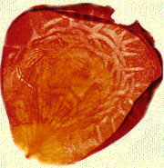
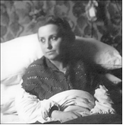

E-BULLETIN NO. 48, DECEMBER 2007
MARIA VALTORTA READERS’ GROUP, AUSTRALIA
11 Best Street, Ringwood, Vic. 3134. Tel. +61 3 9879 7853
E-mail: valtorta@alphalink.com.au
Web-site: http://valtorta.alphalink.com.au

(Jesus to Maria): “Let us turn to the little sheep, seeking to be
acquainted with their Master. It is I, and you are the staff,
leading them to Me.” (The Poem of the Man-God, Vol. 1, p. 246)

“Publish this work as it is… whoever reads it will understand…”
The Lord bless you and keep you; The Lord make His Face shine upon you, and be gracious to you; The Lord lift up His countenance upon you, and give you peace.
(Num. 6:24-6.)

– Pope Pius XII (26th February 1948)
“Lord, I do not ask You for the glory of your visions, but for the grace to love You more and more.” (Notebooks 1944, p. 439.)

EDITORIAL

Dear fellow pilgrims,
Many times during my travels, people have told me how their readings of The Poem of the Man-God and Maria Valtorta’s other writings spoil them for reading other spiritual books. That has been my experience also. Maria’s writings are like the kingdom of Heaven for me:

“The kingdom of heaven is like treasure
hidden in a field, which a man found and covered up;
then in his joy he goes and sells all that he has
and buys that field.” (Mt. 13:45.)

Can you imagine how much the dictations and visions must have meant to Maria herself – receiving them from Jesus first-hand! In 1943, she wrote:
“I am no longer able to get interested in books for reading. I, an obstinate reader, now let books stagnate without opening them. If I do open them, after a few lines I get tired and close them…” (Notebooks 1943, p. 448)
The very next day Jesus said to her:
“You spoke correctly. It is to chew on straw, and I want you to nourish yourself on pure wheat. Straw does not nourish; it fills without nourishing. And so it is with a great deal of science… Souls do not need science, but light. For science there are already too many volumes and too many of the learned. Give the words of Wisdom to the multitudes. And give them with words of wisdom drawn from Me…”
(Notebooks 1943, pp. 450-52)
I know that some readers, who have been lovers of The Poem of the Man-God for many years, have been unaware of the value of the six other “essential” volumes of Maria Valtorta’s writings: her Autobiography, her Notebooks 1943, 1944 and 1945-50, The Book of Azariah (Maria’s Guardian Angel), and the just-translated dictations of the Holy Spirit: Lessons on the Epistle of St. Paul to the Romans (now available!). In the chronology of Maria’s journey, and immediately after her Autobiography, Notebooks 1943 contains the first nine-months series of dictations received (mainly) from Jesus and Mary, and could be regarded as her formation material, immediately after which Jesus began to give her His visions and dictations of The Poem.
Perhaps these first dictations could be used by others as a teaching course towards becoming a saint. The timing of this thought may have been planted in my tiny mind by the Holy Spirit (don’t I want to become a saint too?). A few months ago, after much procrastination, I opened my well thumbed 626-page Notebooks 1943 and re-read the beautifully written Preface by the translator (my namesake – see this bulletin’s supplement). This got me going – different from the “technical” exercises with booklets and audios I’ve been assembling for many years, and now focusing more on my own spiritual development. My latest reading of this book now completed, and I’ve substantially augmenting its (now six-page) Thematic Index – which I can send to interested readers.
I often think that the further up the mountain I go - in my journey with Maria Valtorta’s writings - the higher the mountain becomes. In Italy early last year, I was thinking aloud to my travelling companion Father Jorge Fuentes, “there ought to be a university of the writings of Maria Valtorta”. God willing, some day this could well be.

At Last! – Maria’s Last Essential Work, in English!
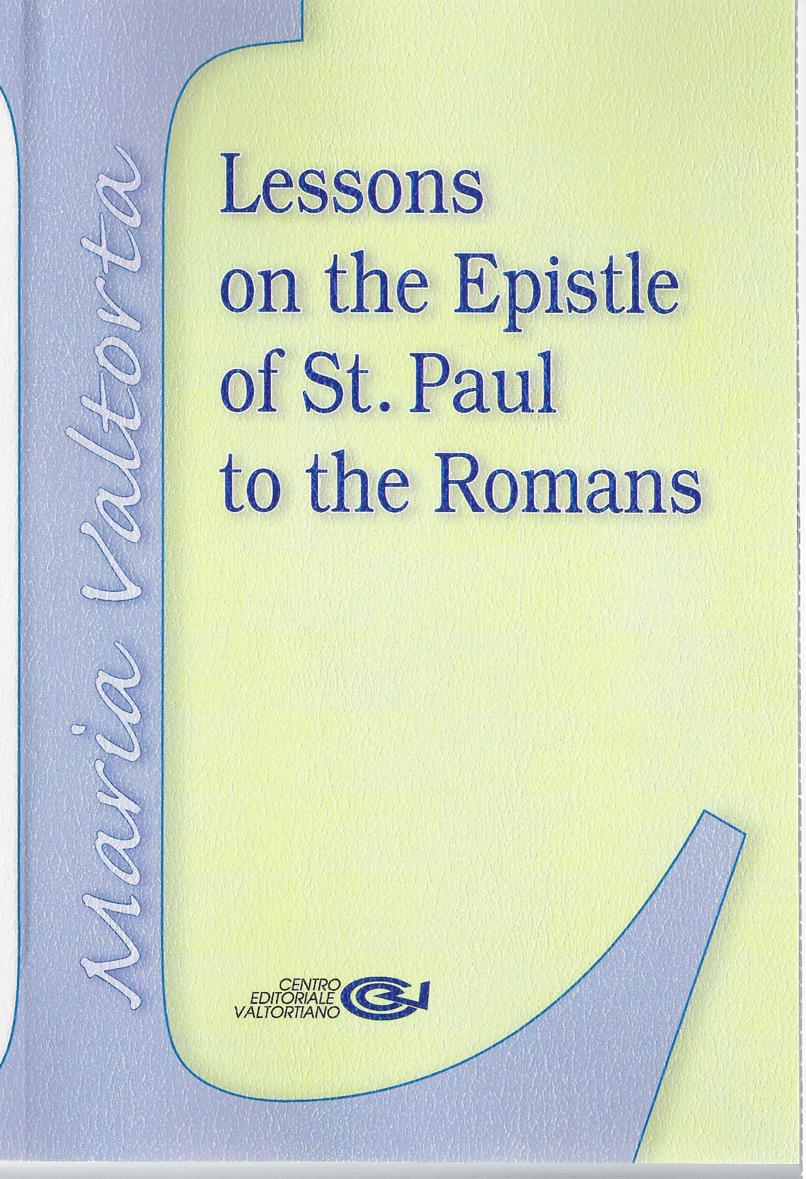
The English translation of the Holy Spirit’s Lessons on the Epistle of St. Paul to the Romans (soft-covered, 310 pages) – has now arrived. All of our first consignment has been pre-sold, so let me know if you want a copy sent from Australia when the next shipment arrives in January. The cost is $Aust 36.00 ($Aust 32.60 for pensioners & religious), plus postage.

(On Christmas Day, 1943, The Eternal Spirit gave a (then rare) dictation to Maria Valtorta:)
"I am Love. I do not have my own voice, because my Voice is in the whole creation and beyond the creation. Like the ether, I spread through all that is; like fire, I inflame; like blood, I circulate.
"I am in every word of Christ and flower on the lips of the Virgin. I purify the mouths of the prophets and saints and make them luminous. I am He who inspired things before they existed, for it is my power that, like a heartbeat, moved the creative thought of the Eternal…"
(Notebooks 1943, p. 601)
----------
FR. SZABLEWSKI’S DVDS
On a recent trip to Adelaide, I met Father Marian Szablewski, a Polish priest who has directed two plays drawn from the text of The Poem of the Man-God – entitled “The Messiah Has Come” and “The Resurrection”. These were filmed in Polish dialogue with very skilled amateur players, and professionally made into DVDs – with English sub-titles. For further information, contact Father Marian at 3 Venning St. Morphett Vale S.A. 5162, Australia, email: mszabl@tpg.com.au , phone +61 8 8384 8749,
MARIA VALTORTA’S QUADERNETTI
Mention was made in Bulletin # 47 of a little “Valtorta” booklet of about 250 pages, still only in Italian, entitled Quadernetti (Little Notebooks). The webmaster of http://www.bardstown.com/~brchrys/index.html - an excellent Valtorta web-site – has translated the following small passages (listed under the heading “Selections from Maria Valtorta’s Other Mystical Revelations”):
The Holy Spirit: Wars & Natural Disasters; Christ Speaks on Publishing The Poem...; Christ Teaches About Predestination; Christ on the Our Father & Hail Mary; Christ Speaks on Pagan Sages; Christ on Reactions to The Poem...; and On Free Will & Opposition to The Poem.
----------
WHAT ABOUT RELATIVES?
(An excited Marie Williams, who lives close by, says how thrilled she was to read this passage from the booklet “Jesus Teaches us to Evangelize – what to do and what not to do”.)

(Jesus is speaking to one of His cousins, about the difficulties of facing opposition within his family(1), concerning his becoming Jesus’ disciple…)
« …God is more than father, mother, brothers. I have come to join people not according to the world, to flesh and blood; but according to the spirit and to Heaven. I therefore must separate flesh and blood, to take with Me the souls which, even when on this world, are fit for Heaven, to take the servants of Heaven. So I have come to call the "strong ones", and make them even stronger, because My army of meek people is made of "strong" people. Meek towards their brothers, strong against their own ego and the selfishness of family blood.
Do not cry, My cousin. I can assure you that your pain is operating before God in favour of your father and brothers - more than any word, not only yours, but also Mine. Believe Me, words cannot enter where preconceived ideas form a barrier. But Grace enters. And a sacrifice draws graces…
The first enemies of those who are called, are their relatives(2). But we must learn to distinguish between love and love, and to love in a supernatural way. That is to love more the Master of the supernatural, than the servants of the Master. We must love our relatives in God. But not more than God… »
(1) See also where “no prophet is accepted in his own country”: Mt. 13:57; Mk. 6:4;
Lk. 4:24; Jn. 4:44. (2) See Mt. 10:34-6; Lk. 12:51-3. (3) See Mt. 10:37.
----------
MARY TALKS OF LOVE AND EVANGELIZING
(Ed Ford, from Scottsdale AZ, USA, was moved by this passage – also included in the “Evangelize” booklet.)

(Believing that the time is fast approaching when she will be re-united with Jesus in Heaven, Mary tells John the apostle about there being no limits to the love She has given to God:)
« ...I know that - for those who make use of it - it is strength, light, magnet that attracts upwards, fire that purifies and beautifies what it burns, transforming and trans-humanising those caught in its embrace. Yes. Love is really a flame. Although the flame destroys what is perishable - be it a wreck, some rubble, or a poor wretch - it makes a purified spirit of it, worthy of Heaven.
How many wrecks, how many men who are stained, corroded, worn out, you will find on your ways of evangelizers! Do not despise any of them. On the contrary, love them, so that they may reach love and be saved. Infuse love into them. Many a time man becomes wicked, because no one ever loved him, or he was loved badly. Do love them, so that the Holy Spirit, after the purification, may come to dwell again in those temples, those which many things made empty and filthy. God, to create man, did not take an angel or choice materials. He took some mud, the most worthless material. Then infusing His breath into it(1) - that is, His love again - He elevated the worthless material to the sublime rank of adoptive son of God. My Son, on His way, found many wrecks of men who had fallen into filth. He never trampled on them despisingly. On the contrary, He gathered them and received them, and He changed them into chosen souls of Heaven. Always bear that in your minds. And do as He did. Remember everything of the actions and the words of My Son. Remember His kind parables. Live them, that is, put them into practice. And write them, so that they may remain for future generations, to the end of time, and they may always serve as a guide for men of good will, to achieve life and eternal glory. You will certainly not be able to repeat all the bright words of the Eternal Word of Life and Truth(2). But write as many of them as you can. The Spirit of God - Who descended upon Me so that I might give the Saviour to the world(3), and Who descended also upon you a first and a second time(4) - will help you to remember(5), and when you speak to the crowds, in order to convert them to the true God. » (Vol. 5, pp. 927-8)
(1) Gen. 2:7; (2) See Jn. 21:25; (3) Mt. 1:18-25, Lk. 1:26-38; (4) Jn. 20:19-23,
Acts 2:1-4; (5) Mt. 10:19-20, Mk. 13:11, Lk. 12:11-12, Jn. 15:26-7.

Thou shalt smile, and have a nice day…
It frustrates those who have other plans for thee.

“BE PERFECT”
(Jesus says:)
"It is natural for the devil to try to disturb you. He can no longer do so with the flesh, and he thus tries to disturb your spirit.
"He does what is his occupation - that is, tries to discourage souls, terrify them, make them waver. He generally tries to make them sin to distance them from Me. When he is unable to do this - because the soul is quite watchful and the deceit does not enter - he then tries to terrify it and introduce thoughts which are apparently good, but in reality harmful.
"See, Maria. Between the thought 'I will become holy' and the thought 'It is impossible for me to become holy' - the more dangerous and contrary to Me is the latter. The first is not an act of pride, if it is corroborated by all the efforts of the will to reach holiness.
"I stated, 'Be perfect as is my Father'. In so saying, I did not give you a mere exhortation, but a sweet command, providing you with the measure of perfection: that of God, the Most Perfect One. For I would have wanted you all perfect, so as to have you around Me eternally.
"The soul must thus tend towards sanctity, and tell herself, 'I want to become holy', unhesitatingly, tirelessly. Do you recognize you are weak? But I know better than you that you are weak, and yet I told you, 'Be perfect', for I know that if you want to, with my help, you can be perfect - that is, holy.
"The Evil One does not want this. He well knows - for he is very intelligent - that when a soul has taken the first step on the way of holiness, and has tasted the first mouthful of holiness - whose taste is ineffable - she develops a yearning for holiness and is lost to him. He then creates thoughts of false modesty and distrust: 'It is not possible for me to merit Paradise. No matter how good God is, is it possible for Him to forgive and help me? Is it possible for me, even with his help, to be able to satisfy Him? I am good for nothing!'
"Or he hisses his insinuations. 'But do you think you can become holy? What you experience, hear, and see is illusions of a sick mind. It is your pride that makes you conceive them. You - holy? But don’t you remember this… and this… and this? And don't you remember what Christ said? In thinking this way, you commit a new sin, the same one I did. You think you are like God…'
"Let him hiss. He does not deserve a reply. What you experience is from God; what you think is my desire reflecting itself in you. It is thus something holy. I told what my sign is. It is peace. When you feel peace in yourself, it is a sign that what you experience, hear, see, and think - is something from God. Continue without hesitating. I am with you.
"When our Enemy tries to bother you too much, say: 'Hail Mary, Mother of Jesus, I entrust myself to you'. The devil feels even more repugnance at the name of Mary than at my Name and my Cross. He is unable, but tries to harm Me: in my faithful, in a thousand ways. But just the echo of the name of Mary sets him to flight. If the world were able to call Mary, it would be saved.
"To invoke our two Names together is thus a powerful way to bring down and break all the weapons which Satan hurls against a heart that is mine. Alone, souls are all nonentities, weakness. But the soul in grace is no longer alone. She is with God.
"So when the other disturbs you with reflections of false modesty or fear, you must always think, 'It is not I who think I am holy, but it is Jesus who wants me to be so. It is we - Jesus and I, God and I - who want this to happen for his glory'.
"Didn't I say, 'When two are gathered together to pray, the Father will grant them what they request'? But what will happen when One of the two is Jesus Himself'? Then the Father will grant the grace requested in a full, well-shaken, abundant measure. For the Son is powerful in regard to the Father, and all things are made in the name of the Son." (Notebooks 1943, pp. 85-7)

LETTERS
(From Australia unless stated otherwise)

The Maria Valtorta Books
Ever since I was told, and read for myself, I have believed these writings. I feel like an apostle... It is a new life inside me, a new fire, the fire of the Holy Spirit to have us burn with the desire to serve Our Lord and Savior Jesus Christ. I even pray to Maria Valtorta. And imagine! She was doing this during WW2! I was 5 years old in 1941, even at that age I can remember so much of what the world was like during that time. Never in all the years of growing up in school and high school did I ever hear of these writings. Never during my life until now.
ELVIRA DONAGHY, Ridgefield CT, USA.

I first read The Poem of the Man-God in 1995. Since then I continue to read it over and over again. Besides readings at Mass, The Poem is my main way of praying. I came across your website and I must say thank-you for doing something about this great work. I will be much obliged to be a part of any group that studies this work.
FRANK DE SILVA, Brisbane, Qld.

As I had lent Volumes 1 and 2 of The Poem, I now find the 1943 Notebooks of Maria just as uplifting and inspiring to meditate and contemplate on each day. My younger brother (a Policeman in NSW) cannot wait to have his hands on it, but he has to wait a bit, for I am a slow reader when it comes to this type of material.
Just like the rest of the readers, once I have Volume 1 of the Poem, it is more reading time all over again and again and again...
NESTOR PALMA, Canberra, A.C.T.

"The Poem of the Man-God" - as it is titled in the current English translation, or "The Gospel as it was revealed to me", as it is known in subsequent Italian editions - is now in its fourth Italian edition, and has been translated into many other languages. Cardinal Ratzinger [now Pope Benedict XVI). in private letters. has acknowledged that this work is free from errors in doctrine or morals. The Conference of Italian Bishops has acknowledged the same in its correspondence with the current editor, Dr. Emilio Pisani." (Extract from Bishop Roman Danylak’s web-site: : http://www.bardstown.com/~brchrys/index.html )

The Quarterly Bulletins
I woke up this morning to receive your email [and e-bulletin], and I am so delighted. I am so grateful to be reading this beautiful gift from Our Lord. I feel that I am holding such a treasure to my heart. Thank you so much for your work. I'm also finding that I don't feel free to tell many people about it yet, only a select few. I am sure I will, to more people, when I feel Jesus prompting me. Have others experienced that caution, too? My normal way is to let everyone know.
KAREN PATENA, Cleveland OH, USA.
(Yes, it’s hard to hold back on that “normal way”. But I try to remember what worked for me when I went off the rails some years ago: “I was more influenced by how others lived their lives and by what they believed in, than by how they wanted me to live my life and what they wanted me to believe in.” So I pray that the Holy Spirit will touch souls through me. Which amounts to a pretty significant responsibility for me, to model my own life as a first priority. Then I’m careful to not drop any hints about what I believe in, until I first see a spark of interest coming from the other person. Maybe the little booklet “Jesus Teaches Us to Evangelize – What to Do, and What Not to Do” could be a help. – Ed.)

I just wanted you to know how much I appreciate receiving your bulletins.
CAMIEL DESCHUTTER, St. Clair MI, USA.
I want to thank you, and to inform all the devoted readers of revelations made to Maria Valtorta by LORD JESUS, that I’ve translated parts of the attachments you’ve sent me, to my family and to friends whom we are attending Rosary with. RADU SERBAN, Romania.

Thank you for the bulletin which arrived today. Much food for thought in that, isn't there? I agree with your comments about the 1943 Notebooks - so much to mull over, and so much still to learn. Why didn't I start twenty years before I did? SUE CARROLL, Belmont, Qld.

Thank you so very much for the latest bulletin, I am reading it with great joy. It is great to be still in touch with the Readers Group… I have found a wonderful little house in Collevalenza where there is a Sanctuary of “Amore Misericordioso” - Divine Love. It is a very similar set up to Lourdes in France, and has ‘baths’ and a large basilica. A very spiritual place, and my new home is 5 minutes walk from there. It was a great find. Praise God for His Goodness…
PAMELA NASSUATO, Collevalenza, Umbria, Italy
(Pamela, formerly Pamela Young and then living in Melbourne, participated in our original recording of “The Gospel Meditated Rosary”, some years ago – Ed.)

The Booklets and Audios
Thanks so much for the booklets you have sent me. They are wonderful compilations – so meaningful and encouraging. MICHELE CROUCH, Clayton South, Vic.

I enjoyed listening to your recordings very much, and the bulletins are also a source of inspiration.
GUY LEMICHEL, Toulouse, France.

”My Journey with Jesus”
I was able to listen to and also download your talk as well as the track on the Magi*. May you be blessed for your dedication.
I became acquainted with Maria Valtorta's writings when I borrowed the 1st volume from a relative, who had been sent the book by a clergyman from Switzerland. After reading the book I begged the padre to mail me the literature as well; which he kindly did - all the five volumes! The Poem is sublime; which is not surprising considering who its Author is. I always keep a copy at hand even if I am not reading it.
ROSARY NJANGE, Kenya, Africa
(*The 50-minute CD ”My Journey with Jesus”, is available from the Readers’ Group, and together with the story of the Three Wise Men it can be down-loaded from:
http://www.advancedchristianity.com/Pages/Murray/Murray_001.htm
- part of my friend Tim Fromann’s new Valtorta web-site.)

I enjoyed listening to your (CD) talk that was linked in the last Bulletin… What a beautiful decade you prayed on the Eucharist, using readings from The Poem - Fantastic! I forwarded the link to members of our Legion of Mary Curia in NC and have received a great response to your talk. I am working on getting that same link up to the President of the Arlington VA Regia that our Curia is attached to, so maybe they can put the link to the talk in their minutes/newsletter of the next meeting.
HUGH KELLY, Cary NC, USA.

Radio Maria in Italy
Radio Maria in Italy has been presenting the works of Maria Valtorta for many years. Their nation-wide listening public in Italy is around 3 million strong, and both Pope John Paul and Pope Benedict have made very public their encouragement for this excellent and punctiliously faithful Catholic radio station. Many Cardinals and Bishops participate on a regular basis, and this certainly would not happen if there were even just a hint of something controversial in any of the many program offerings.
The founder and president of the radio station is Padre Livio Fanzaga. He himself was once sceptical about the works of Maria Valtorta - I don't know what it was though that convinced him. Anyhow, Radio Maria is pretty much all over the globe now - and in the course of some 25 years, the Vatican and two Popes have found nothing at all to criticize about the many programs that have been devoted to the works of Maria Valtorta. Radio Maria is tremendously influential among the faithful, and for this reason, the Vatican for sure keeps a close eye - and an attentive ear - on the radio's programming. But it must be said that even in the Vatican, Radio Maria is as popular and well-loved as in any other place in Italy.
CATHERINE DI MATTEO, Latisana (UD), Italy.

The “Sunday Gospels” 4xCD (MP3) audios
Thank you for the "Sunday Gospels". They really enrich my Gospel knowledge.
FATHER MARIAN SZABLEWSKI, Morphett Vale, S.A.
(If readers don’t have the “Sunday Gospels” set, you can down-load the Gospel tracks for the current month by visiting Steve Jost’s web-site: http://www.valtorta.org – then scroll down to: Click HERE to HEAR Gospels of Sundays & Feasts of the current month – Ed.)

† R I P †
Please pray for the souls of
Sheila Simpson, mother of Nancye Simpson of East Burwood Vic., who died on 26th August 2007, aged 98 years;
Anna Vozary, mother of Ilona Maros of Sadlier NSW, who died on 7th September 2007,
aged 95 years; and
Leslie Gordon Phillips, father of Peter Phillips of Springvale Vic., who died on 19th September 2007,
aged 95 years.

Maria Valtorta Readers’ Group
This group is a non-profit organisation, which retails publications of Maria Valtorta’s writings, and offers other supporting materials, to its members and to other interested persons. Bulletins are sent to members every 3 months. A subscription of $10.00 per year (a little extra if mailed overseas, and no charge for priests and religious) is requested. (E-mail copies of the bulletins and supplements, convenient for Valtorta readers outside Australia, are now free.) A Catalogue of books and other items is available on request.
The writings of Maria Valtorta are considered by many to be among the most wonderful gifts given by Jesus to His followers and would-be followers in the twentieth century. The Readers’ Group has much material available which supports their authenticity as Private Revelation. If you receive just a fraction of the knowledge, understanding and inspiration from Maria’s revelations on the lives of Jesus and Mary, as testified by our readers, you will be very blessed. May God inspire us all, in our journeys to holiness.

[The material in this publication is not intended to represent the opinion of the Church. The editor affirms submission to the official judgement of the Church regarding the information contained herein.]

